Java Interface
Another way to achieve abstraction in Java, is with interfaces.
An interface is a completely "abstract class" that is used to group related methods with empty bodies:

Example
// interface
Interface Animal {
Public void animalSound(); // interface method (does not have a body)
Public void run(); // interface method (does not have a body)
}

To access the interface methods, the interface must be "implemented" (kinda like inherited) by another class with the implements keyword (instead of extends). The body of the interface method is provided by the "implement" class:
Example
Interface Animal {
Public void animalSound(); // interface method (does not have a body)
Public void sleep(); // interface method (does not have a body)
}
Class Pig implements Animal {
Public void animalSound() {
System.out.println(“The pig says: wee wee”);
}
Public void sleep() {
System.out.println(“Zzz”);
}
}
Class Main {
Public static void main(String[] args) {
Pig myPig = new Pig();
myPig.animalSound();
myPig.sleep();
}
}

Notes on Interfaces:
- Like abstract classes, interfaces cannot be used to create objects (in the example above, it is not possible to create an "Animal" object in the MyMainClass)
- Interface methods do not have a body - the body is provided by the "implement" class
- On implementation of an interface, you must override all of its methods
- Interface methods are by default abstract and public
- Interface attributes are by default public, static and final
- An interface cannot contain a constructor (as it cannot be used to create objects)

Why And When To Use Interfaces?
1) To achieve security - hide certain details and only show the important details of an object (interface).
2) Java does not support "multiple inheritance" (a class can only inherit from one superclass). However, it can be achieved with interfaces, because the class can implement multiple interfaces. Note: To implement multiple interfaces, separate them with a comma (see example below).
3) By interface, we can support the functionality of multiple inheritance.
4) It can be used to achieve loose coupling.
As shown in the figure given below, a class extends another class, an interface extends another interface, but a class implements an interface.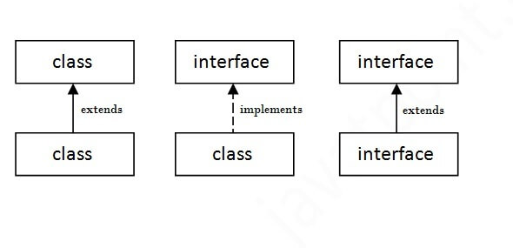

Java Interface Example

In this example, the Printable interface has only one method, and its implementation is provided in the A6 class.

Interface printable{
Void print();
}
Class A6 implements printable{
Public void print(){System.out.println(“Hello”);}

Public static void main(String args[]){
A6 obj = new A6();
Obj.print();
}
}

Example 2
//Interface declaration: by first user
interface Drawable{
void draw();
}
//Implementation: by second user
class Rectangle implements Drawable{
public void draw(){System.out.println("drawing rectangle");}
}
class Circle implements Drawable{
public void draw(){System.out.println("drawing circle");}
}
//Using interface: by third user
class TestInterface1{
public static void main(String args[]){
Drawable d=new Circle();//In real scenario, object is provided by method e.g. getDrawable()
d.draw();

}}

Interface Example: Bank
interface Bank{
float rateOfInterest();
}
class SBI implements Bank{
public float rateOfInterest(){return 9.15f;}
}
class PNB implements Bank{
public float rateOfInterest(){return 9.7f;}
}
class TestInterface2{
public static void main(String[] args){
Bank b=new SBI();
System.out.println("ROI: "+b.rateOfInterest());
}}

Multiple Interfaces
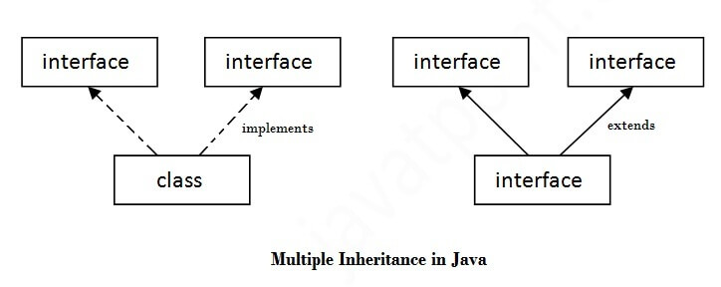
To implement multiple interfaces, separate them with a comma:

Example
interface FirstInterface {
public void myMethod(); // interface method
}

interface SecondInterface {
public void myOtherMethod(); // interface method
}

// DemoClass "implements" FirstInterface and SecondInterface
class DemoClass implements FirstInterface, SecondInterface {
public void myMethod() {
System.out.println("Some text..");
}
public void myOtherMethod() {
System.out.println("Some other text...");
}
}

class Main {
public static void main(String[] args) {
DemoClass myObj = new DemoClass();
myObj.myMethod();
myObj.myOtherMethod();
}
}

